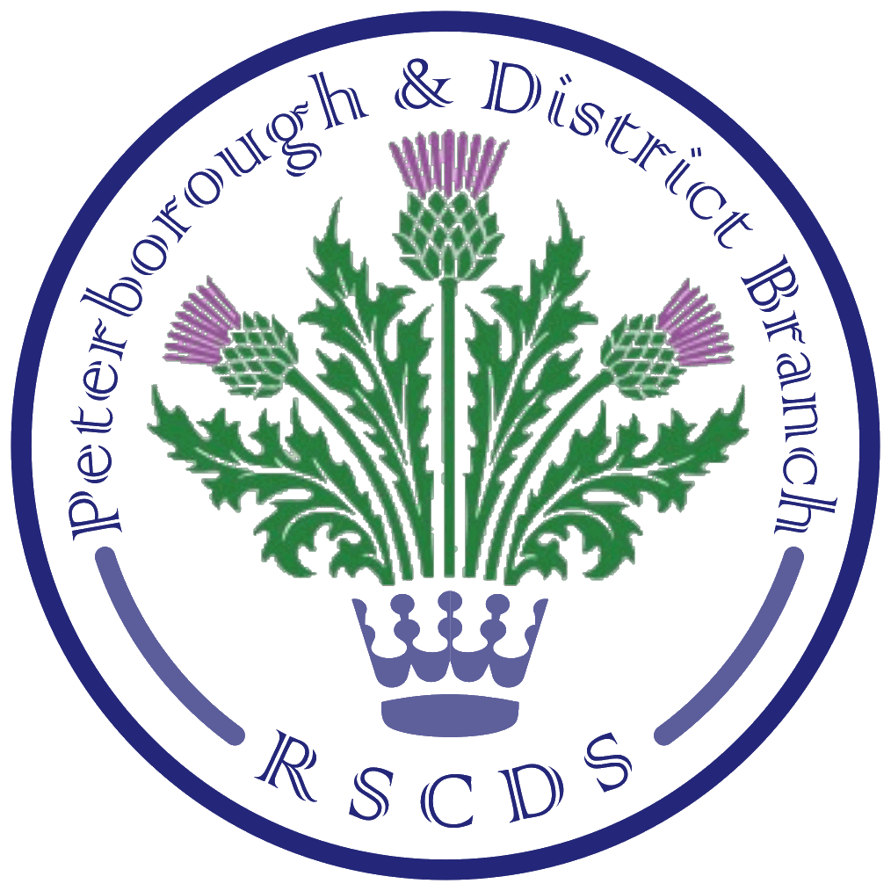
The Royal Scottish Country Dance Society
Peterborough & District Branch

Chairman: Amanda Peart; Vice Chairman: James Williams; Membership Secretary: Brenda Parkes; Treasurer: Ian Arnott; Secretary: Sheila Lewins, 23 Wentworth Drive, Oundle PE8 4QF; sheilalewins@hotmail.co.uk

Website: www.peterboroughrscds.org.uk



December Dancing
Our last Tuesday class in 2018 will be a social on Tuesday 11 December, 7.30 pm – 10 pm at St Mark’s Church Hall, PE1 2SN (please note the later finishing time). Please bring a small plate of food to share at the interval. Our charity this year is Multiple Sclerosis: if you would like to donate to this charity instead of / as well as exchanging Christmas cards (please do not feel you have to do both), there will be a collection tin available on 4 December as well as 11 December. Classes begin again on Tuesday 8 January 2019.

Our last Tea Dance in 2018 will be on Friday 14 December, 3 pm – 6 pm, at Newborough Village Hall, PE6 7RT. You will find the programme, crib and link to videos on our website.

Mandy Baxter’s Birthday Dance is on Saturday 8 December: please be sure to let Mandy know by 1 December if you will be there.

Burns’ Supper Dance
Our Burns’ Supper Dance will be held on Saturday 26 January 2019 at St Andrew’s Church Hall, PE3 9RF, 6 for 6.30 pm arrival, cost £12 per person. Our piper, Ian Baca, will welcome us and then pipe in the haggis. Supper will be followed by dancing from approximately 8.30 pm – 10.15 pm. Dances will be walked through at least once, and all dancers are very welcome to join us. Dances on the programme are as follows, and you will find both the crib and link to videos on our website:
Ecclefechan Feline
City of Belfast
The Piper and the Penguin
Flora’s Fancy
Miss Milligan’s Strathspey
Blooms of Bon Accord
Inchmickery
Mr Iain Stuart Robertson
Girardet House
The Highland Rambler
We need to know numbers for catering, so please help us by reserving your place by 14 December. Payment in advance would be greatly appreciated please: this may be made to Jean Norris at Tuesday class or at our Tea Dance on 14 December; alternatively, arrangements can be made for you to send payment by cheque if you email Sheila or Amanda.

If anyone is willing to help with food preparation, please sign up at Tuesday class.
There will be a raffle on the night in aid of Multiple Sclerosis: prizes welcome in advance.
More Dates for your 2019 Diary

Advanced Class Dates
24 January, 28 February, 28 March
Please note that these dates are provisional and depend on there being sufficient dancers able to attend: Sheila will email as usual just before each date. All experienced dancers are very welcome to join us, 7.30 pm – 9.30 pm, at St Mark’s Church Hall.

Friday Afternoon Tea Dances
8 February, 5 April, 20 September, 1 November, 13 December
All Tea Dances will be 3 pm – 6 pm, at Newborough Village Hall.
Please note that there is NO TEA DANCE in May 2019 (the one scheduled for 17 May has been cancelled)
At the Tea Dance held on 28 September 2018, our cake raffle raised £127 for Macmillan Cancer Support, in memory of Rhona Murray. Thank you very much to everyone who contributed to this.

Newark Day School: Saturday 19 January 2019
On Saturday 19 January, Newark SCD Society will be holding a Day School, where the morning session is devoted to beginners and those who wish to develop their knowledge of the basics of SCD. There is also the option of an afternoon session for more experienced dancers, and a Social Dance in the evening. We would highly recommend this Day School, particularly to our beginners and those who have taken up dancing within the past couple of years. More details and application forms available at Tuesday class.

Peterborough & District RSCDS AGM: Tuesday 14 May 2019

Summer Dance
Our Summer Dance will take place on Saturday 18 May 2019 and will take on a different format from usual; dancing will be 3 pm – 6 pm at Newborough Village Hall. More details nearer the time.

Visiting Teacher
Provisional date, to be confirmed: Tuesday 21 May 2019: Gill Mouncer, a Scottish Country Dance teacher from Leicester, has been invited to teach our last class of the 2018-19 year. Some of you will have already met Gill when she taught us in June 2018. Gill is an excellent teacher, and we do hope that dancers from all SCD groups/clubs, beginners and the more experienced, will support this class.

Annual Dance
Our Annual Dance will be on Saturday 12 October 2019, dancing to Ian Slater. More details later.

A note from your Committee:
We are trying to think of ways in which to encourage new teachers and the continuation of Scottish Country Dancing in our area and would welcome your suggestions.
One idea put forward is to set aside a sum of money to sponsor someone wishing to attend a teachers’ course: would this be useful to you or to someone you know? In return we would ask for some teaching help with classes. This, along with other ideas you may have, will be discussed at our next Committee meeting on 9 February 2019, so do please speak to a Committee member if you have any views on this, or on any other matter relating to our Branch activities.

Merry Christmas and a Guid New Year to you all!

