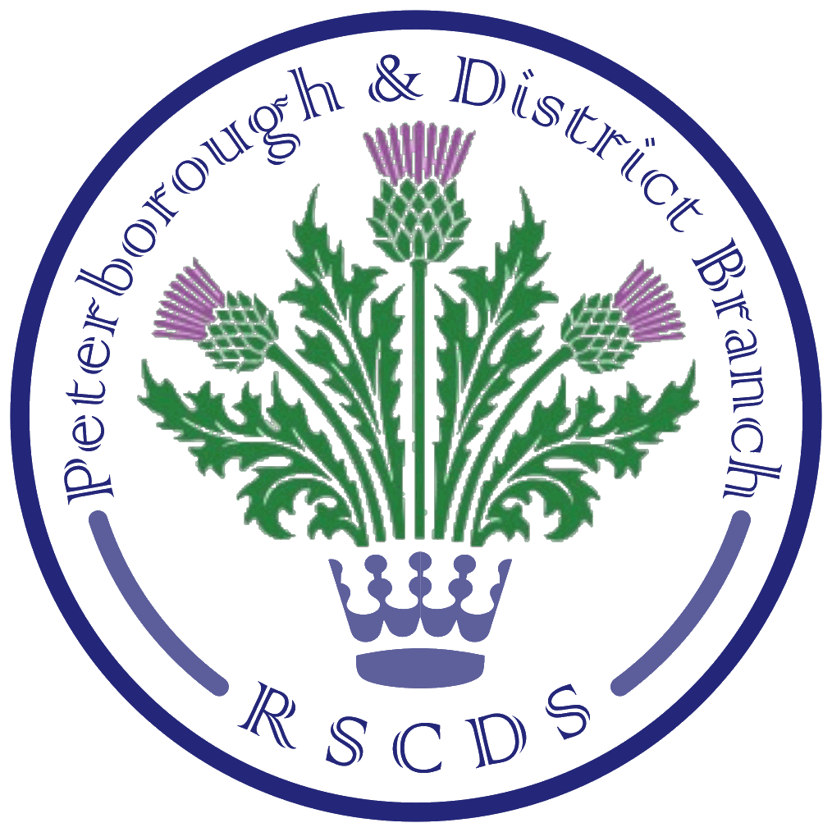
The Royal Scottish Country Dance Society
Peterborough & District Branch

Chairman: Amanda Peart; Vice Chairman: James Williams; Membership Secretary: Brenda Parkes; Treasurer: Ian Arnott; Secretary: Sheila Lewins, 23 Wentworth Drive, Oundle PE8 4QF; sheilalewins@hotmail.co.uk

Website: www.peterboroughrscds.org.uk



Peterborough & District RSCDS (PRSCDS) Tuesday Classes
- Peterborough & District SCD classes resume on Tuesday 3 September 2019,
7.30 pm – 9.30 pm, at St Mark’s Church Hall, Peterborough PE1 2SN.
- Please do bring along friends/neighbours/relatives, as September really is a good time for beginners to join us. Posters advertising our classes are available from Sheila.
- Classes will run until Tuesday 10 December, our Christmas Social, 7.30 pm – 10 pm.
- Please note that there are no classes during the month of August.
- Forthcoming Dances of the Month: Napier’s Index (September), Jennifer’s Jig (October), The Duke of Perth (November), Lady Sophia Lindsay (December)

PRSCDS Advanced Classes: New Venue!
Advanced classes will be held on the following Thursdays:
19 September, 17 October, 21 November
We have reverted to dancing on the third Thursday of the month in order to have the opportunity to change our venue. These three classes will be held at:
Colonel Dane Memorial Hall, Church Street, Alwalton PE7 3UU
Sheila will be sending an email nearer the time to check on advanced dancers’ availability on these dates and on possible travel requirements, as we are aware that some dancers may need a lift.

Friday Afternoon Tea Dances
Tea Dance dates are as follows, 3 – 6 pm, at Newborough Village Hall, PE6 7RT, cost £5:
4 October, 1 November, 13 December
(No Tea Dance in September)

New Class Fees
New weekly class fees from September 2019:
£2 for RSCDS members; £4 for non-members
Dancers attending more than 10 classes will benefit from paying the RSCDS membership fee (£20 single; £32 for a couple at the same address). Most of our regular dancers have now paid their 2019-2020 RSCDS subscription, but if you have not, then it is not too late – just contact Sheila as soon as possible in order to be able to take advantage of the reduced class fees from September.
(Our former yearly £3 class subscription will be waived for 2019-20.)

RSCDS (Royal Scottish Country Dance Society) Membership and Website
As indicated above, it really does pay to join RSCDS if you attend PRSCDS classes on a regular basis. As part of your membership, you will receive regular news from RSCDS via their eNewsletter, and you will also receive the ‘Scottish Country Dancer’ magazine in October and April. However, if you have joined RSCDS and wish to be removed from either mailing list, then please let Sheila know.

The RSCDS has recently revamped their website: www.rscds.org Here you will find useful resources for dancers and teachers (with explanations and short video clips of steps and formations), information on events and classes throughout the world and on many other matters relating to SCD.
In order to see additional ‘Member Only’ content and to take advantage of Member discounts on items from the RSCDS shop, you will need to log in. To reach the ‘log in’ page, first click on the ‘My RSCDS’ blue button (top right-hand corner). Then:
- If you were a member last year, in 2018: Click on ‘Log In’, then the orange box, then enter your email address. RSCDS will email a link for you to click; this should take you back to the RSCDS website in order to create a password. (Please note that RSCDS members who already had a password will need to set one up again for the new website.)
- If you are a new member in 2019: Click on ‘Register’ and enter your email address and the unique activation code sent to you by Sheila. Click ‘Create New Account’ then follow instructions which will be sent to you by email from RSCDS for setting up a password.

Annual Dance 2019
Saturday 12 October: Peterborough & District RSCDS Annual Dance, 7.00 pm – 10.30 pm,
St Andrew’s Church Hall, PE3 9RF, dancing to Ian Slater. Raffle prizes welcome.
2020 Dates to Save
Saturday 25 January: Peterborough & District RSCDS Burns’ Supper Dance
Saturday 16 May: Sheila’s Birthday Dance/PRSCDS Dance, dancing to Ian Slater

Further details of events mentioned above, including cribs and video links, will appear, in due course, on our website: www.peterboroughrscds.org.uk You will also find dates and details of dances organized by other local groups on the website.

Thank you!
- Thank you to all dancers who gave up their spare time to take part in dancing at the Castor and Ashwell Village Fetes in July. And a special thank you to Hazel Williams for organizing these demonstrations.
- Thank you also to those who attended our Summer Sessions this year with Amanda and James. James always appreciates dancers’ comments on his new dances.

Charity
Our charity for 2019-20 is The Samaritans, in memory of Betty Hay, who worked for them for many years. We shall be donating the money raised from our 2019 Summer Dance raffle, our 2019 Christmas Collection and our 2020 Burns’ Supper Dance raffle.

Other Classes/Events
- Stamford Scottish Country Dance Club classes resume on Monday 2 September,
7.30 pm – 9.30 pm, at Ryhall Village Hall, PE9 4HR. Please note there is no dancing
on Monday 16 September.
- The Sunday Class meets on 8 September at Eastwell Village Hall and on 29 September at Castle Bytham Village Hall, 4.30 pm – 7.30 pm, but there are no classes in October. Further dates and more information on The Sunday Class website: www.thesundayclass.org.uk or if you wish to receive the NewsE-mail, please contact: amandapeart@thesundayclass.org.uk
- Beginners Ceilidh/Scottish Dancing, Monday evenings, 7.30 pm - 9pm, at Braceborough Village Hall: contact Hazel Williams for further details: 01778 560417

