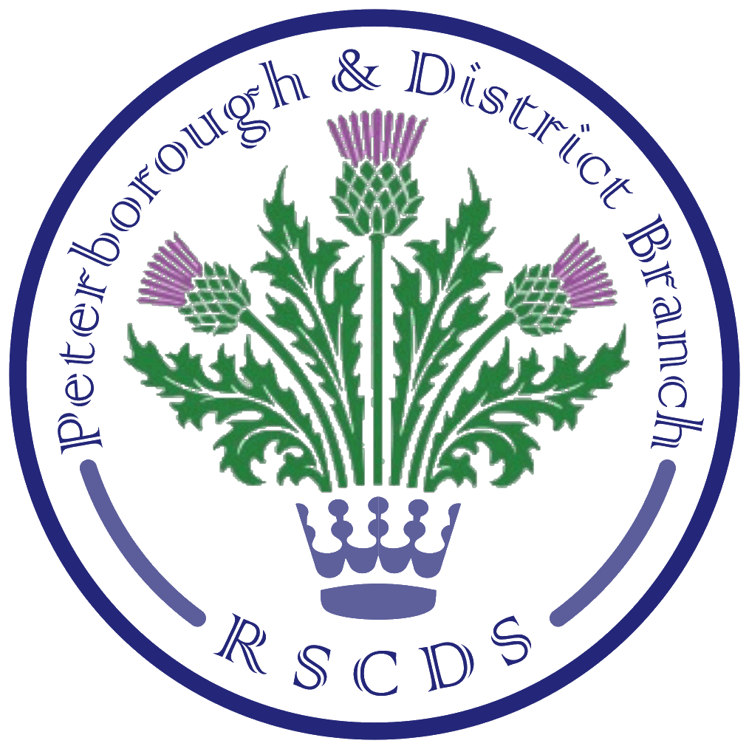
The Royal Scottish Country Dance Society
Peterborough & District Branch

Chairman: Amanda Peart; Vice Chairman: James Williams; Membership Secretary: Brenda Parkes; Treasurer: Ian Arnott; Secretary: Sheila Lewins, 23 Wentworth Drive, Oundle PE8 4QF; sheilalewins@hotmail.co.uk

Website: www.peterboroughrscds.org.uk



Our last Tuesday class in 2019 will take place on
Tuesday 10 December, 7.30 pm – 10 pm
at St Mark’s Church Hall, PE1 2SN (please note the later finishing time). Please bring a small plate of food to share at the interval. Our charity this year is The Samaritans, in memory of Betty Hay: if you would like to donate to this charity instead of / as well as exchanging Christmas cards (please do not feel you have to do both), there will be a collection tin available on 3 December as well as 10 December.

Our last Tea Dance in 2019 will be on Friday 13 December, 3 pm – 6 pm, at Newborough Village Hall, PE6 7RT. You will find the programme, crib and link to videos on our website.

Classes begin again on Tuesday 7 January 2020. Forthcoming Dances of the Month: The Gentleman (January) and J.B. Milne (February).

********************
Our Burns’ Supper Dance will be held on Saturday 25 January 2020 at St Andrew’s Church Hall, PE3 9RF, 6 for 6.30 pm arrival, cost £12 per person. We are very grateful to our piper, Ian Baca, who reserved this date for us a whole year ago; he will welcome us and then pipe in the haggis as usual. Supper will be followed by dancing from approximately 8.30 pm – 10.15 pm. Dances will be walked through at least once, and all dancers are very welcome to join us. There will be a raffle on the night in aid of The Samaritans: prizes welcome in advance. Dances on the programme: New Year Jig, Butterscotch & Honey, Duke of Perth, Rothesay Rant, St Columba’s Strathspey, Lady Sophia Lindsay, Jennifer’s Jig, A Trip to Bavaria, The Gentleman, The Highland Rambler. Link to crib and videos can be found on our website.

We need to know numbers for catering for our Burns’ Supper, so
please help us by reserving your place by 13 December 2019.
Payment in advance would be greatly appreciated: this may be made at Tuesday class or at our Tea Dance on 13 December; alternatively, arrangements can be made for you to send payment by cheque if you email Sheila or Amanda. (Cheques will not be cashed until Jan.)

Please let us know if you are able and willing to supply a pudding (expenses will be reimbursed). We are also looking for volunteers to do the washing & drying up of dishes; we need two teams of 3 or 4 people in order to allow everyone to join in the dancing at some point.

More Dates for your 2020 Diary
Advanced Class Dates: 16 January, 19 March
All experienced dancers are very welcome to join us, 7.30 pm – 9.30 pm, at our new venue, Colonel Dane Memorial Hall, Church Street, Alwalton, PE7 3UU. These classes are dependent on there being sufficient dancers, so please ensure that Sheila knows you will be attending.

Friday Afternoon Tea Dances:
14 February, 27 March, 12 June, 2 October, 6 November, 11 December
All Tea Dances will be 3 pm – 6 pm, at Newborough Village Hall.

Visiting Teacher
Gill Mouncer has kindly agreed to teach us on Tuesday 18 February 2020, 7.30 pm – 10 pm, at St Mark’s Church Hall, PE1 2SN. We do hope that dancers from all SCD groups/clubs, beginners and the more experienced, will support this special class.

Peterborough & District RSCDS AGM: Tuesday 12 May

Summer Dance: Saturday 16 May - Please keep the date free!
You are all invited to join Sheila for her 65th Birthday Celebration on Saturday 16 May 2020; as this is normally the time of year when we hold our Summer Dance, the two occasions will be combined into a Ceilidh/Scottish Country Dance, dancing to the wonderful music of Ian Slater and in aid of Cancer Research. The dance will be held at Barnwell Village Hall, near Oundle, 3 pm – approx. 7.30 pm.

RSCDS Membership
- Thank you to everyone who has joined RSCDS or renewed their membership this year.
- You should have received your copy of the ‘Scottish Country Dancer’ magazine in October. If not, then please be sure to contact Sheila.
- There is the option of receiving the magazine digitally instead of by post, and some of you have already chosen this option. If you wish to change the format you currently receive, then please inform Sheila before April when the next magazine is due.
- If you have joint membership, please be aware that a digital copy of the magazine will be sent to only one email address, so do please forward to your partner/spouse.
- We hope you have had a chance to look at the new RSCDS website: most information can be accessed without logging in. However, if you do wish to log in, for example to make a discounted purchase from the RSCDS shop, and have any problems doing so, then please ask Sheila or email RSCDS direct.

New RSCDS Book: 30 Popular Dances Volume 2
The new RSCDS book and accompanying CDs are now on sale via the RSCDS website; Amanda also has some copies at the same price minus postage. Each Branch had put forward 8 dance suggestions for inclusion, and it might interest you to know that 3 of our choices have been selected: J.B. Milne, The Dream Catcher and Pelorus Jack, so other branches obviously enjoy these too!

Contact Details
A reminder to please let Sheila know if your contact details change; if we have your correct email address, postal address and phone number then we can keep you informed.

Merry Christmas and a Guid New Year to you all!

