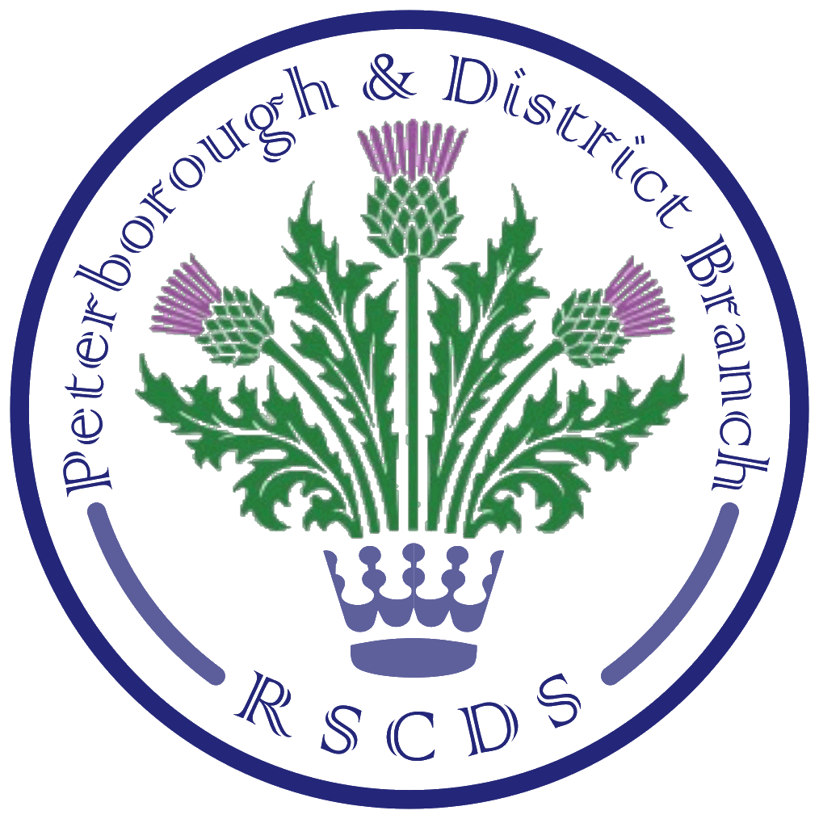
The Royal Scottish Country Dance Society
Peterborough & District Branch

Chairman: James Williams; Vice Chair: Amanda Peart; Treasurer: Mandy Baxter; Secretary: Sheila Lewins,
23 Wentworth Drive, Oundle PE8 4QF; sheilalewins@hotmail.co.uk

Website: www.peterboroughrscds.org.uk



Isn’t it great to be back dancing?
We are now planning for future events, which you will find listed below.
To help our dancing continue, hopefully without any hitch, we ask all dancers to please take heed of the Covid advice outlined at the end of this newsletter. Thank you.

Friday 10 December, 3 pm – 6 pm
Tea Dance at Newborough Village Hall, PE6 7RT.
You will find the programme, crib and link to videos on our website.

Tuesday 14 December, 7.30 pm – 10 pm (please note the later finishing time)
Last class of the year / Social Evening at St Mark’s Church Hall, PE1 2SN.
Please bring your own drink, and either your own snack or a small plate of food to share at the interval. Our charity for the year is Head to Toe: if you would like to donate to this charity instead of / as well as exchanging Christmas cards (please do not feel you have to do both), there will be a collection tin available on 7 December as well as 14 December.

Tuesday 4 January 2022
Classes begin again at St Mark’s Church Hall, PE1 2SN, 7.30 pm – 9.30 pm

Saturday 29 January 2022
Burns’ Supper Dance at St Andrew’s Church Hall, PE3 9RF, 6 for 6.30 pm arrival
Cost £15 per person: payment in advance by 10 December 2021 please
We may have to limit numbers, so please book early; if you leave it till January, you could be disappointed. Payment may be made at Tuesday Class / at our December Tea Dance / by post (Sheila Lewins, 23 Wentworth Drive, Oundle PE8 4QF). Cheques should be made payable to ‘Peterborough and District RSCDS’. We will need to know contact details and if you have any dietary requirements at the time of booking.


Help with catering and washing up: we need volunteers to
- provide cooked & mashed potatoes or mashed swede (for 10 people), to be kept warm in a slow cooker (Expenses will be reimbursed)
- help with washing / drying of dishes
If you think you can help at all, please let us know as soon as possible.

There will be a raffle on the night in aid of Head to Toe (tickets £1 per strip). Raffle prizes welcome in advance. You will find the programme, crib and link to videos on our website.

More Dates for your 2022 Diary
Advanced Class Dates: 24 February, 24 March
All experienced dancers are very welcome to join us, 7.30 pm – 9.30 pm, at Colonel Dane Memorial Hall, Church Street, Alwalton, PE7 3UU.

Friday Afternoon Tea Dances:
11 February, 18 March, 13 May, 3 pm – 6 pm, at Newborough Village Hall.

Easter Break (no Tuesday class): 12 and 19 April

Peterborough & District RSCDS AGM: Tuesday 10 May

Last Tuesday Class: 24 May
*************
RSCDS Membership Subscriptions
Thank you to everyone who has kept up their RSCDS membership. As you know, because there was no dancing during the Covid pandemic lockdown, our Branch decided to subsidise subscriptions this year and pay half the membership fee from Branch funds for existing members renewing in July 2021; single membership therefore entailed a cost of only £9 instead of £18 for 2021-22.

In November 2021, RSCDS held their AGM, where a motion was put forward to increase subscription fees from £18 to £25 (single membership, with other membership subscriptions based pro-rata on this amount). Amanda and Sheila, as Branch delegates, did vote against this motion, but unfortunately it was carried. The increase in fees will therefore take effect in July 2022.

New Secretary
We shall need a new Branch Secretary in May 2022. You do not need to be already on the Committee and Sheila would, of course, be happy to help out initially. Could this be you? Please let us know.

Covid Advice
Our aim is to keep you all safe during these Covid times, so here are a few things you can please do to help; this applies to all Peterborough & District RSCDS classes/events:
- If you feel at all unwell, then please stay away!
- If someone in your household has Covid symptoms, then stay away
- If you have had contact with someone who has Covid symptoms, or you yourself have symptoms or have tested positive, please follow government advice on isolation
- We recommend that all attendees at classes/events keep up to date with vaccinations
- Please be respectful of others’ personal space, particularly when not dancing
- Sanitise hands on arrival and throughout the evening, between dances; we encourage you to bring your own sanitiser, although there will be a supply in the hall.
- Bring your own cold drink/mug for tea or coffee
- Make sure that we have your current contact details before attending an event
- If you develop Covid symptoms of any kind following a dancing class/event, please be sure to email/phone: sheilalewins@hotmail.co.uk / 01832 272280 so that others may be informed of a potential close contact
- Keep an eye on your emails for news relating to dancing, particularly immediately prior to turning up for a class/event, as cancellations may have to be made

Take Care and Stay Safe, everyone
Merry Christmas and a Guid New Year to you all!

