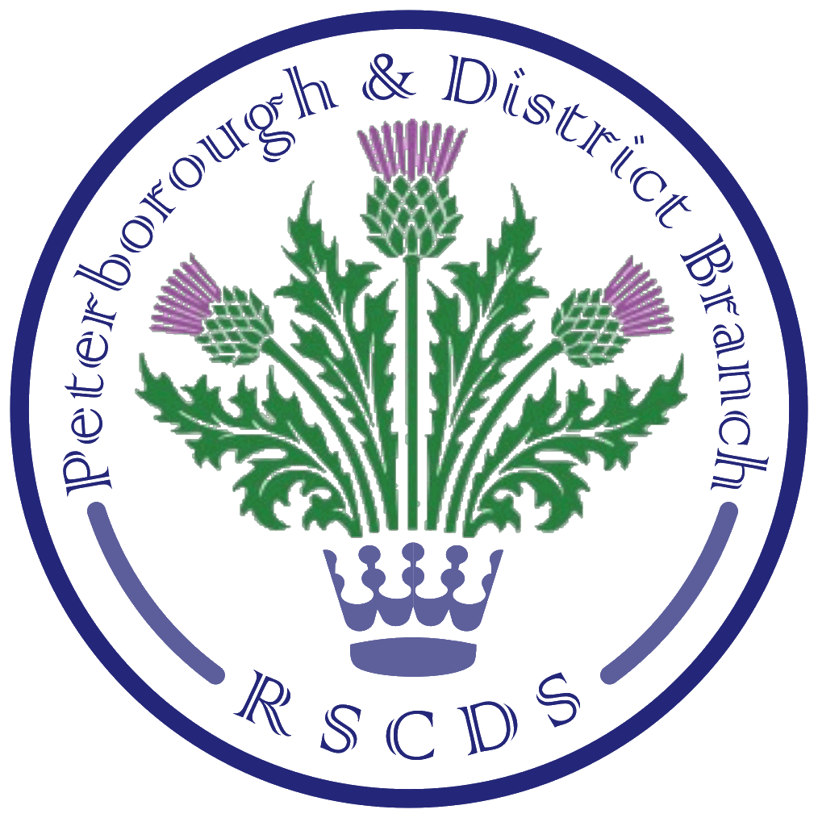
The Royal Scottish Country Dance Society
Peterborough & District Branch

Honorary President: Maimie Clarkson; Chairman: James Williams; Vice Chairman: Amanda Peart; Treasurer: Amanda Baxter; Secretary: Sheila Lewins, 23 Wentworth Drive, Oundle PE8 4QF; sheilalewins@hotmail.co.uk

Website: www.peterboroughrscds.org.uk



Charity Raffles
At our Ruby Anniversary Dance in October 2021, the raffle raised £134.10 for this year’s charity ‘Head to Toe’; thank you to all who donated. As our January raffle did not take place due to the cancellation of our Burns’ Supper Dance, we have decided to have a Raffle at the next Tea Dance on 18 March, to raise a bit more for ‘Head to Toe’, so please bring along extra cash!

Branch AGM
This year’s AGM will take place at 7.30 pm on Tuesday 10 May, in St Mark’s Church Hall. All class members are encouraged to attend. We shall keep the meeting as brief as possible to allow time for dancing afterwards, and the evening will be free of charge.

At our AGM, as you know, we elect next year’s PRSCDS Committee and make other decisions relevant to our Branch, so please try to be there if you can.


New Secretary Required!
Sheila will be standing down in May, having reached the end of her second five-year stint as Secretary. We need someone to take over – can you help? Please note: You do NOT have to be an existing Committee Member before taking on this role.

New ordinary Committee Members very welcome!
Although current Members are willing to stand again, it would be great to have a new face or two on the Committee to give us fresh ideas and help with running the Branch.

Branch Delegates
Amanda and Sheila have been our Branch Delegates for a few years now, and could continue, but if anyone else would like to take this on, then please do let us know.

Please, please give the above your careful consideration and let any of the current Committee know – preferably before April when AGM papers will be sent out - if you can help by volunteering as Secretary / Committee Member / Branch Delegate. If you would like to know more about what might be involved before volunteering, then please just ask.

Dates for your Diary
(Further details of all our events and those organised by other local SCD groups can be found on our website www.peterboroughrscds.org.uk under ‘Area Diary’)

Stamford Dance: Saturday 5 March, *5.30 – 9.30 pm*, Ryhall Village Hall, Church Street, PE9 4HR

Advanced Class: Thursday 24 March, 7.30 pm – 9.30 pm at Colonel Dane Memorial Hall, Church Street, Alwalton PE7 3UU. Please let Sheila know in advance if you can attend.

Friday Afternoon Tea Dances: 18 March & 13 May, 3 pm – 6 pm, Newborough Village Hall, PE6 7RT. Raffle on 18 March in aid of ‘Head to Toe’.


Easter Break: 12 April and 19 April – NO Tuesday class

AGM followed by dancing: Tuesday 10 May, 7.30 pm – 9.30 pm, St Mark’s Hall, PE1 2SN

Last Class of the Season: Tuesday 24 May, 7.30 pm – 10 pm, St Mark’s Hall, PE1 2SN
Dancing from 7.30 pm till 10 pm. You are welcome to bring a small amount of food.

***************************

Summer Sessions (7.30 pm – 9.30 pm, at St Mark’s)
Tuesday 7 June, Tuesday 21 June, Tuesday 12 July, Tuesday 26 July
Please let us know if you have any suggested topics/dances for these sessions.
(Tuesday 7 June: Committee Meeting at 6.30 pm, before dancing for all begins at 7.30 pm;
Tuesday 21 June will be a practice for our Summer Dance.)

Summer Dance
Saturday 25 June, *4 pm – 8 pm*, at Newborough Village Hall, PE6 7RT

RSCDS Annual Subscriptions due: 1 July (More details nearer the time)

Advance Notice of Dates for 2022-23
Tea Dances: 7 October, 11 November, 16 December 2022
Stamford Dance, 4 pm – 8 pm, dancing to Ian Slater, Ryhall Village Hall: 15 October 2022
Burns’ Supper Dance: 28 January 2023

***************************

Please remember to bring your own cup (& plate when needed) to classes, tea dances and other events in order to reduce the amount of plastic we use. Thank you.

