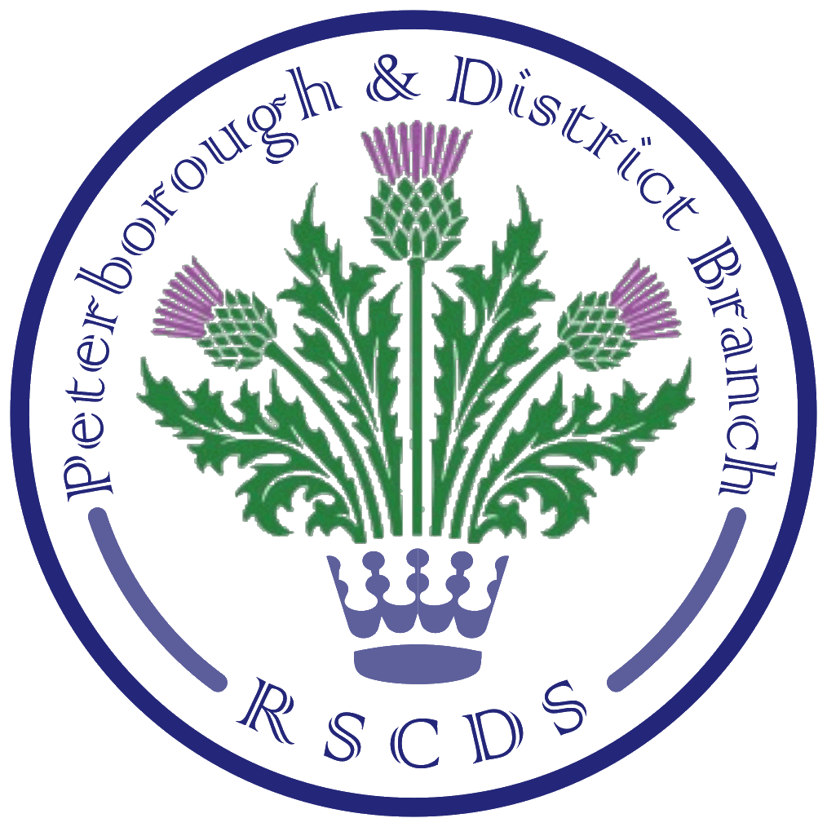
The Royal Scottish Country Dance Society
Peterborough & District Branch

Chairman: Amanda Peart; Vice Chairman: James Williams;
Secretary: Sheila Lewins, 23 Wentworth Drive, Oundle PE8 4QF; sheilalewins@hotmail.co.uk
Membership Secretary: Brenda Parkes; Treasurer: Eleanor Rayden

PRSCDS Website: www.peterboroughrscds.org.uk

(Note: Peterborough & District RSCDS has been abbreviated to PRSCDS throughout this newsletter.)

General Classes
PRSCDS classes resume on Tuesday 5 September, 7.30 pm – 9.30 pm, at St Mark’s Church Hall, Peterborough PE1 2SN. Classes will run until Tuesday 12 December, which will be our Christmas Social, 7.30 – 10 pm. (Please note that, as announced at our AGM, there will be no St Andrew’s Meal this year.) A plea from our teachers: please make every effort to arrive at class in good time, so that you have your dancing shoes on and can start dancing at 7.30 pm. And if any friends/neighbours/relatives have shown any interest in Scottish Country Dancing, please do bring them along, as September really is a good time for beginners to join us. Posters advertising our classes are available from Sheila. Please help to spread the word!

Advanced Classes
Advanced classes will be held on the following Thursdays, 7.30 – 9.30 pm, at St Mark’s Church Hall:
21 September, 19 October, 16 November
This is a very relaxed and fun group, and all experienced dancers are very welcome.

Fees: A Reminder
- Hopefully, by now, most of you will have renewed your RSCDS subscriptions for 2017-18. If you have not yet renewed, or wish to join RSCDS, then please contact Sheila as soon as possible.
- Our annual class fees (£3 per member) are due in September, so please remember to pay this to Eleanor on the first Tuesday you attend. Weekly class payments remain the same: £2.50 for RSCDS members; £3 for non-members. Please try to bring the correct change each week.

Tea Dances
Tea Dance dates are as follows, all to be held 2 – 5 pm, at Newborough Village Hall, PE6 7RT, cost £5:
22 September, 3 November, 8 December, 9 February, 6 April, 11 May

PRSCDS 36th Anniversary Dance
Saturday 14 October, 7 pm – 10.30 pm, at St Andrew’s Church Hall, PE3 9RF, dancing to Ian Slater. Raffle prizes welcome. Programme, cribsheet and video link can be found on the PRSCDS website: www.peterboroughrscds.org.uk Tickets: £10 (please reserve in advance)

Burns’ Supper Dance 2018
Please make a note of the date in your diary: Saturday 27 January 2018.

Summer Dance held on 24 June 2017: A Thank You from Maimie
Maimie Clarkson would like to thank Peterborough & District Branch Committee and all friends who attended the Branch Dance at Newborough on 24 June 2017 to celebrate her 80th birthday. Apart from compiling the programme for the evening, she was not permitted to do any further organising; this was undertaken by the Committee who did a superb job, and everyone who attended had a most enjoyable evening. Maimie is very grateful for the many cards she received and says a special ‘thank you’ to the Peterborough Branch for the card signed by not only the Tuesday class members but also many friends from elsewhere who attended the Dance. And a huge ‘thank you’ from Maimie for the very generous gift card – she says she will have great pleasure in deciding what to buy. Very sincere thanks to everyone who contributed in any way to the success of the Saturday evening, which Maimie reckons to be one of her most enjoyable events in a long connection with SCD! (It was our pleasure, Maimie!)

Congratulations, James!
- ‘Triangulation’, a dance written by James Williams for Bethany Warburton’s 21st birthday, is to be published by New Scotland Country Dance Society (Edinburgh) in their 70th Anniversary Book and has also appeared on their ball programme.
- ‘A Necklace of Coral’, written by James for the Coral Anniversary of PRSCDS last year, appeared this year as the opening dance on an evening programme for the Morland SCD Week and was well received.

Charity Donations
- Our chosen charity this year was The Wildlife Trust and thanks to your generosity, via raffles and last year’s Christmas collection, our Treasurer has just sent a cheque for £250. This donation was made in memory of Pat Middleton, who is very much missed.
- Our charity for the coming year will be decided by the Committee in September. If you have any suggestions for us to consider, please do let us know. (We have already donated, in the past few years, to Air Ambulance, Thorpe Hall, Peterborough Refugees, MND, Parkinson’s.)

Core Dances
There will be a suggestion book available at class for dancers to suggest amendments to our list of Core Dances. Perhaps there is a dance on the current list (which you will find in the suggestion book, or ask Sheila for a copy) which you think has been danced just too many times, or is there one which you think should be added to the list? Please let us know your thoughts via the suggestion book.

DVDs/Videos
DVDs and video clips can be very useful resources for getting to grips with dances/steps/formations.
- The Branch has three DVDs available for dancers to borrow: ‘Reel Scottish Dancing’ and ‘The Red Thistle Dancers (Part 1 & Part 2): please use the signing out book and return after two weeks.
- For our Branch Dance and Tea Dance programmes, you will find a list of video clips set up for you online: go to the Area Diary on our website www.peterboroughrscds.org.uk, find the dance programme under ‘Details’ and click on ‘Watch videos’.

‘The Reel’
The Branch subscribes to ‘The Reel’, a magazine produced by RSCDS London Branch, four times a year. If you would like to see the current copy or be added to the circulation list, please let Sheila know.

Other Classes
- Stamford Scottish Country Dance Club classes resume on Monday 4 September,
7.30 pm – 9.30 pm. Please note venue - Ryhall Village Hall, PE9 4HR
- The Sunday Class meets on 3 September at Eastwell Village Hall and on 24 September at Castle Bytham Village Hall, 4.30 pm – 7.30 pm (dancing from the new RSCDS Book 51 on both dates). Further dates and more information on The Sunday Class website: www.thesundayclass.org.uk
- Beginners Ceilidh/Scottish Dancing, Monday evenings, 7:30 pm - 9pm, at Braceborough Village Hall: contact Hazel Williams for further details: 01778 560417

