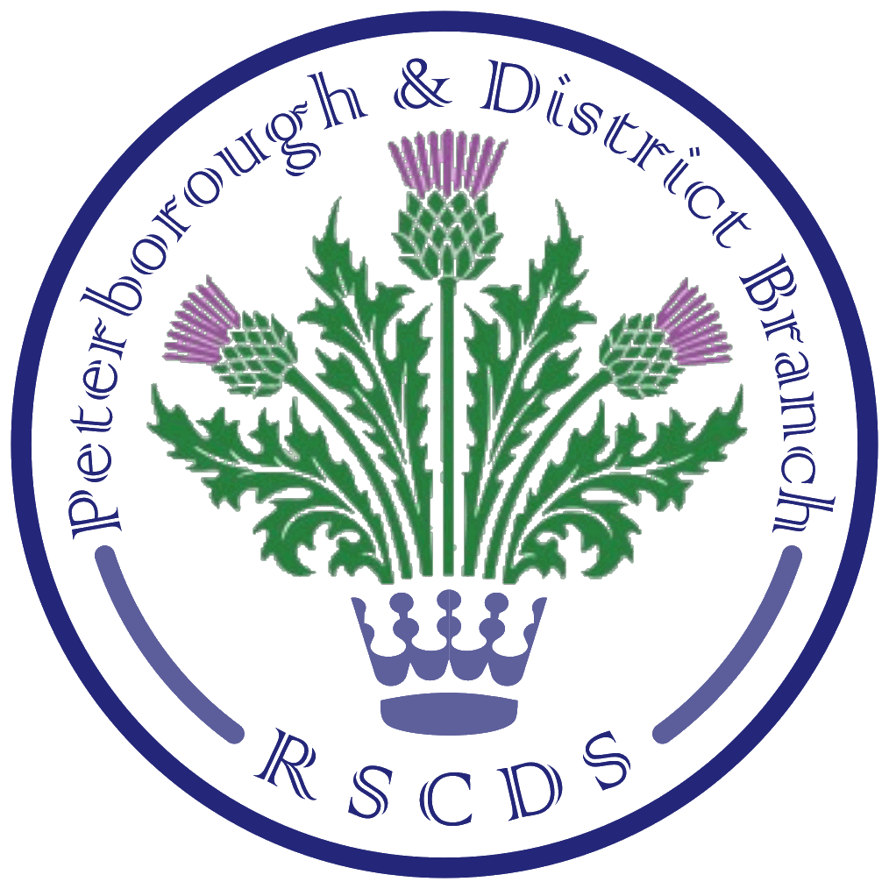
The Royal Scottish Country Dance Society
Peterborough & District Branch

Chairman: Amanda Peart; Vice Chairman: James Williams;
Secretary: Sheila Lewins, 23 Wentworth Drive, Oundle PE8 4QF; sheilalewins@hotmail.co.uk
Membership Secretary: Brenda Parkes; Treasurer: Eleanor Rayden

PRSCDS Website: www.peterboroughrscds.org.uk



Classes:
Our last Tuesday class in 2017 will be a social on Tuesday 12 December, 7.30 pm – 10 pm at St Mark’s Church Hall (please note the later finishing time). Please bring a small plate of food to share at the interval. Our charity this year is The Salvation Army Good Neighbours Scheme: if you would like to donate to this charity instead of / as well as exchanging Christmas cards (please do not feel you have to do both), there will be a collection tin available on 5 December as well as 12 December. There will be a three-week break over Christmas and New Year: classes begin again on Tuesday 9 January 2018.

Advanced Classes:
Following consultation with our experienced dancers, we have decided to try holding advanced classes on the fourth Thursday of each month (instead of the third Thursday when we have usually held this class): this will begin happening in March. There will be no Advanced Class in December, and no Advanced Class in January as several of us will be busy practising for our January demonstration. In February, there is only one Thursday available to us at St Mark’s Church Hall, and this is the first Thursday of that month.

Dates for Advanced Class in 2018 are, therefore, as follows:
Thursday 1 February, Thursday 22 March, Thursday 26 April, Thursday 24 May

Dancing Demonstration at Peterborough Cathedral:
A team of twelve will be performing dances, under Kerry’s guidance, at a Burns’ Supper at Peterborough Cathedral on Friday 19 January 2018, an event which aims to raise funds for the cathedral. Hazel and James will be in charge of the ceilidh which follows the meal.
A reminder to our dem. dancers that our practice sessions will be on Thursday 4 January and Thursday 18 January, 7.30 pm – 9.30 pm, at St Mark’s Church Hall.

Friday Afternoon Tea Dances:
We have been asked to change the time of our tea dances in order to accommodate the playgroup who use the hall before us; from February onwards, therefore, tea dances will be 3 pm – 6 pm.

Tea Dance dates are as follows:
8 December (usual time: 2 pm – 5 pm)
9 February (new time: 3 pm – 6 pm)
13 April (new time: 3 pm – 6 pm) (**please note that this date has changed, i.e. NOT 6 April)
11 May (new time: 3 pm – 6 pm)

Burns’ Supper Dance 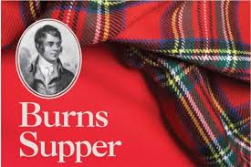
Tickets (£12 per person) for our Burns’ Supper Dance on Saturday 27 January 2018 at St Andrew’s Church Hall, 6 pm – 10.15 pm, are available from Jean Norris at Tuesday class, or by emailing Sheila/Amanda. Please be sure to book your place before we break up for Christmas as this helps us greatly with catering arrangements, and if you are willing and able to help with food preparation, please sign up at class. There will be a raffle on the night in aid of The Salvation Army Good Neighbours Scheme. Raffle prizes in advance please.

Thank You from James Williams
Thank you to all those who turned up at our trial dance sessions over the summer and gave marks out of ten on dances submitted to RSCDS for Book 52, and also on dances written by James; your participation and feedback is very much appreciated.

Scottish Country Dancing Resources
There is a selection of books belonging to PRSCDS which will be available to borrow at Tuesday class from January onwards at no charge, but please enter your name in the signing out book when borrowing. DVDs are also available to borrow at class, as mentioned in the last newsletter.

A new book on Scottish Country Dancing has just been published - Scottish Dance: A Celebration of Scottish Dancing (Collins Little Books) and is available from the RSCDS online shop, from Waterstones or from Amazon, at a cost of £6.99.

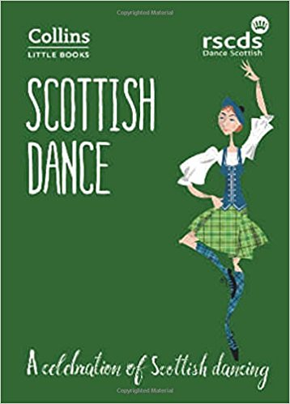

Merry Christmas and a Guid New Year to you all!

